

Name: Ranjitha.R
Reg.No:192421285

Github link:

Ex 11 Create a Static Website and Containerize, Build & Serve it using Docker. Tasks:
  - Create a Simple Static Website (index.html file) with basic HTML content.
  - Write/create a Dockerfile to serve the website using Nginx.
  - Build the Docker Image
  - Run the container:
  - Access the Website using a Browser

AIM
To create a basic static website, package it into a Docker image, and serve it through an Nginx container.

PROCEDURE
- Create a project folder and add an index.html file containing the website heading and message.
- Create a Dockerfile using the Nginx image as the base image and copy the website file into Nginx's web root.
- Build the Docker image using the docker build command.
- Start a container from the generated image and map a host port to the container's Nginx port.
- Open the mapped localhost address in a web browser and verify that the page loads.

INPUT
index.html containing the website content, the Dockerfile, an image name, and a host-to-container port mapping.

OUTPUT
A Docker image is created and an Nginx container serves the static website through the browser.

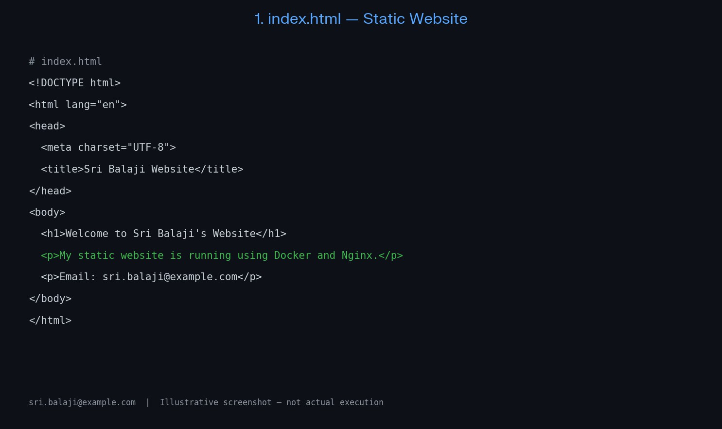

RESULT
Thus, Experiment 11 was carried out according to the given tasks. The expected output and the screenshot evidence are recorded in the original lab document

Ex 12 Create a Simple Python Flask API, Containerize the Application, Build & Push the Image using Docker and Deploy the Application using Kubernetes.
Tasks:
- Create a Simple Flask API by writing a Python file (app.py) with basic endpoints.
- Containerize the Flask App using Dockerfile.
- Build the Image using Docker.
- Push the Image to Docker Hub.
- Create Kubernetes manifests (Deployment YAML & Service YAML) to deploy the application.

AIM
To develop a simple Python Flask API, package it with Docker, push the image to Docker Hub, and deploy it using Kubernetes.

PROCEDURE
- Create app.py with Flask routes, including a home route and a health-check route.
- Create a requirements file and a Dockerfile to install dependencies and run the Flask application.
- Build the Docker image, log in to Docker Hub, tag the image with the repository name, and push it.
- Write Kubernetes Deployment and Service YAML files using the pushed image.
- Apply the manifests with kubectl apply and check the deployment, pods, and service using kubectl commands.
- Access the service and verify that the API responds correctly.

INPUT
Flask source file, requirements file, Dockerfile, Docker Hub repository/image tag, and Kubernetes Deployment and Service YAML files.

OUTPUT
The Flask API is packaged and pushed to Docker Hub, then runs as a Kubernetes pod and is exposed through a service.

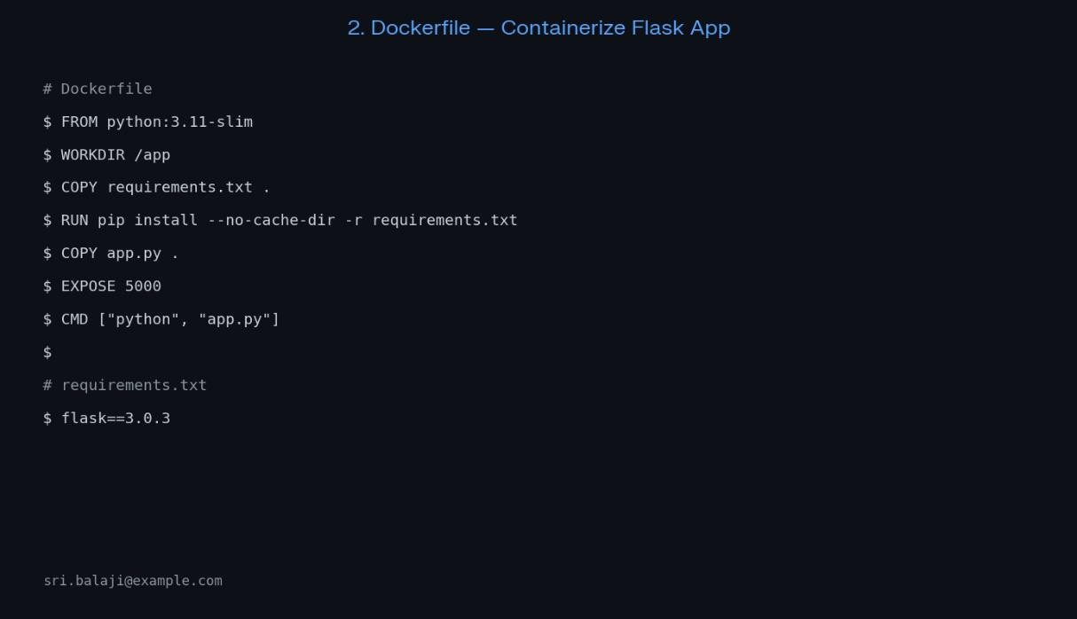
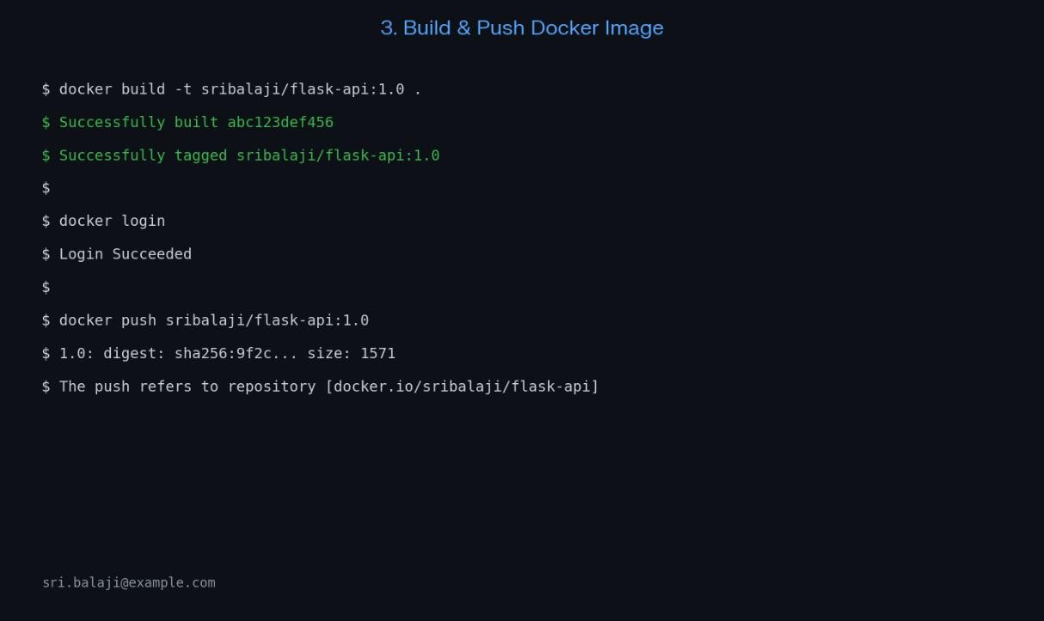
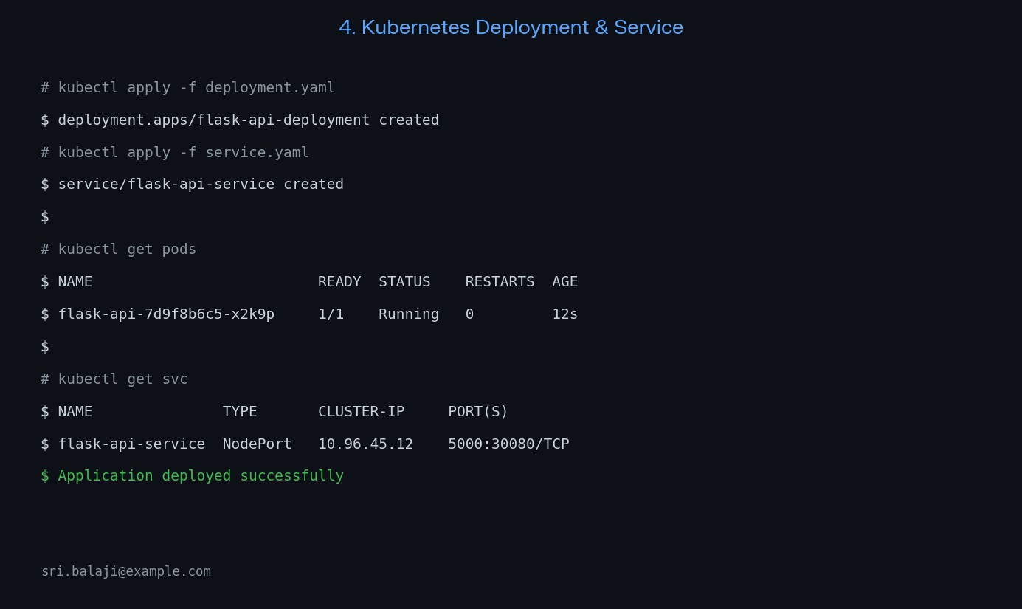
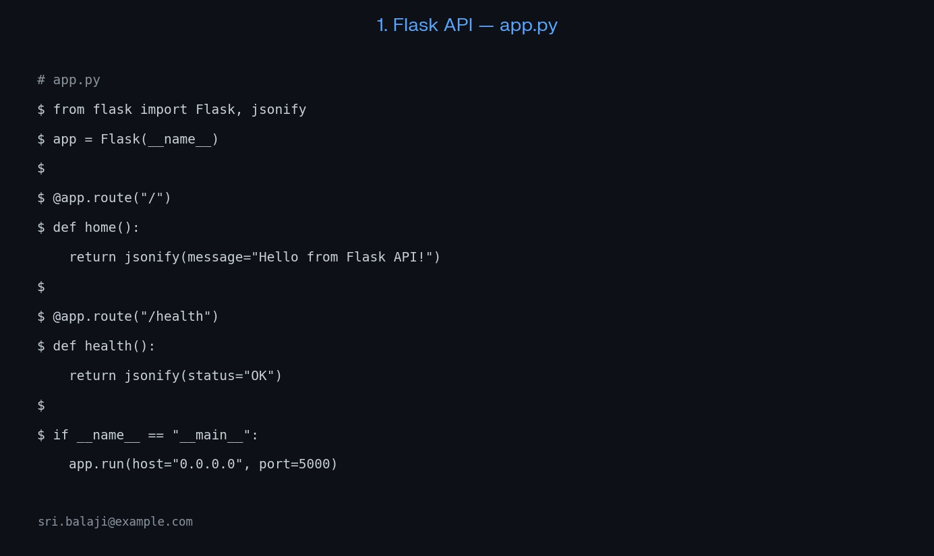

RESULT
Thus, Experiment 12 was carried out according to the given tasks. The expected output and the screenshot evidence are recorded in the original lab document.

Ex 13 Set up a CI/CD pipeline to automate the building, testing, and deployment of a containerized application.
Tasks:
- Set up Jenkins on a local machine or server.
- Create a Dockerfile to containerize a sample application.
- Write a Jenkinsfile to automate the process of building the Docker container, running tests, and deploying to a cloud platform (e.g., AWS or GCP).
- Configure Jenkins to trigg`er builds upon code commits or pull requests.

AIM
To automate the building, testing, and deployment of a containerized application using Jenkins.

PROCEDURE
- Install and start Jenkins on a local machine or server and configure the required tools and credentials.
- Create a sample application and write a Dockerfile to containerize it.
- Add a Jenkinsfile to the repository with stages for checkout, build, test, push, and deployment.
- Configure a Jenkins pipeline job to use the repository and Jenkinsfile.
- Enable build triggers for code commits or pull requests.
- Run the pipeline and inspect each stage's console output to confirm whether the build, tests, and deployment complete.

INPUT
Application source code, Dockerfile, Jenkinsfile, repository URL, and any required registry/cloud credentials.

OUTPUT
Jenkins executes the defined pipeline stages automatically and reports the build/test/deployment status.

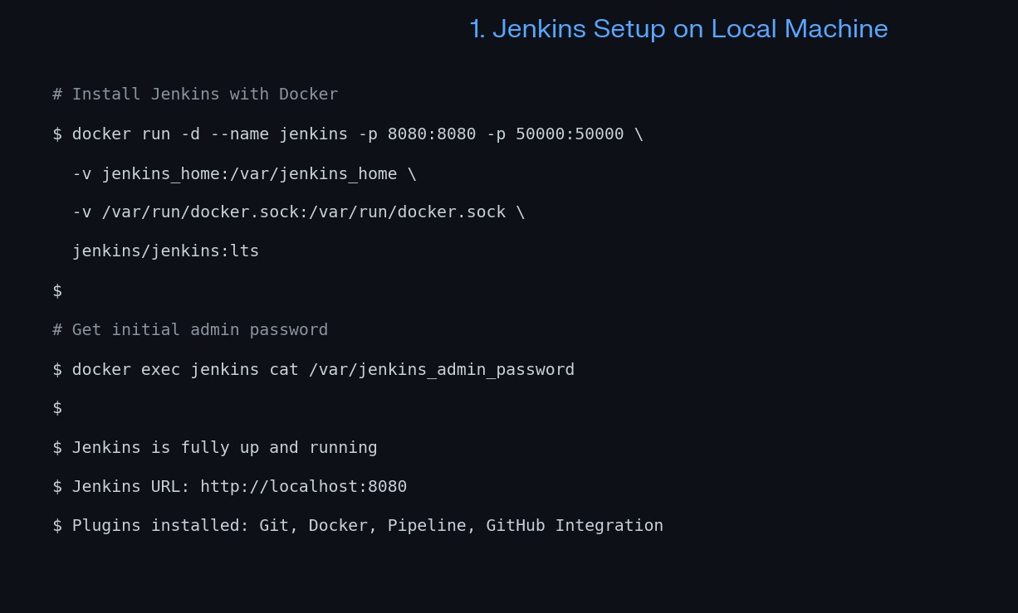
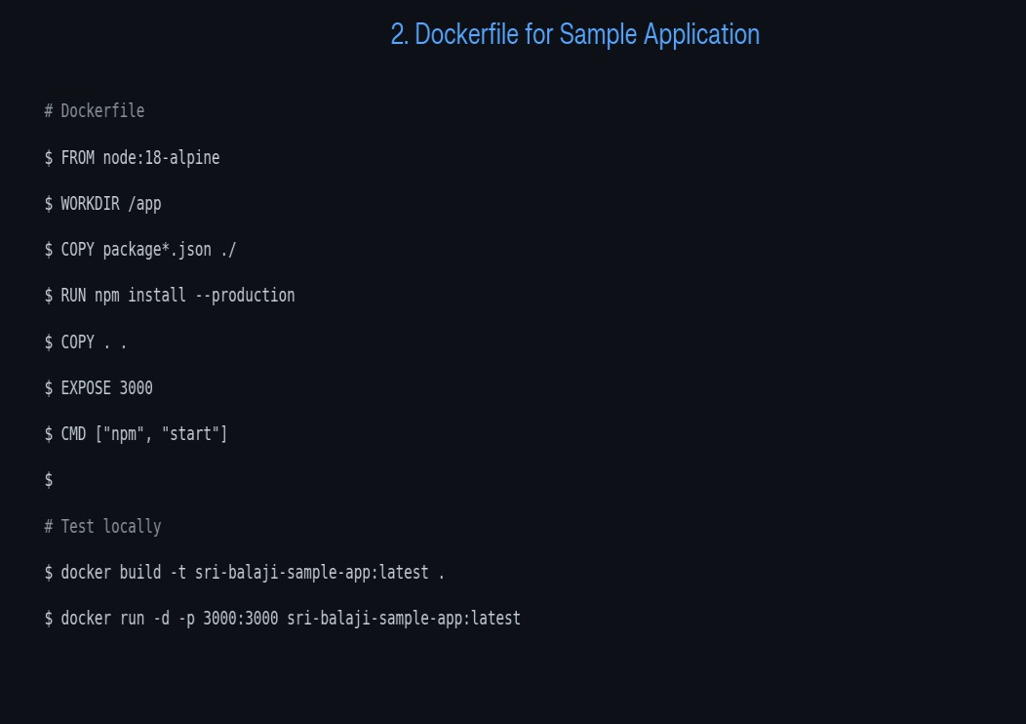

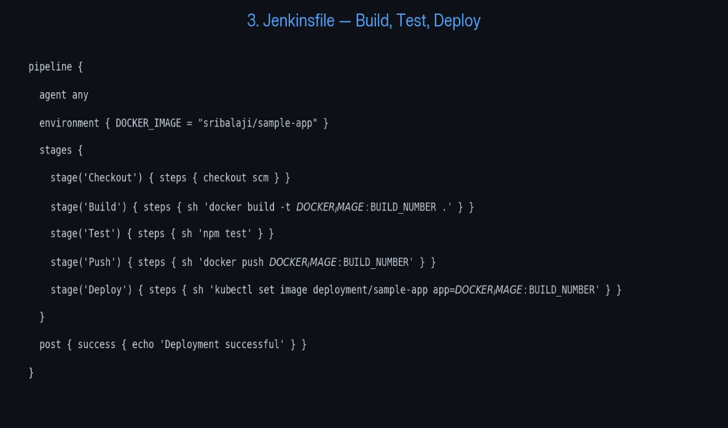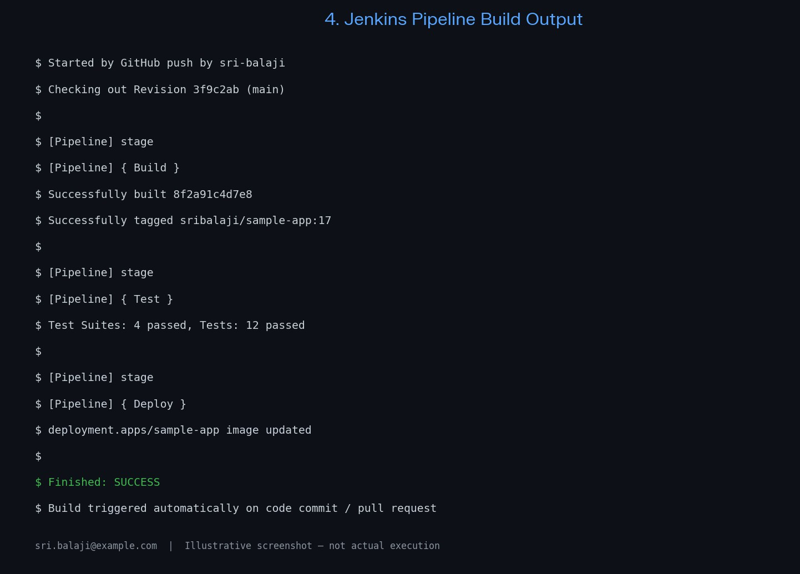

RESULT
Thus, Experiment 13 was carried out according to the given tasks. The expected output and the screenshot evidence are recorded in the original lab document.

Ex 14 Implement Continuous Deployment using GitHub Actions to deploy Dockerized application.
Tasks:
- Set up a GitHub repository and push a simple Dockerized application.
- Create a GitHub Actions workflow to automatically build and push the Docker image to Docker Hub or GitHub Container Registry.
- Automate deployment to a cloud platform (e.g., AWS ECS, Azure Kubernetes Service, or Google Kubernetes Engine).
- Test the CI/CD pipeline by pushing new code changes and verifying that the deployment occurs automatically.

AIM
To automate Docker image building, publishing, and application deployment using a GitHub Actions workflow.

PROCEDURE
- Create a GitHub repository and push the Dockerized application source code and Dockerfile.
- Create a workflow YAML file inside .github/workflows.
- Configure workflow triggers, such as pushes to the main branch.
- Add steps to check out the repository, build the Docker image, authenticate to the container registry using repository secrets, and push the image.
- Add the deployment step for the selected cloud platform and configure the required credentials securely.
- Push a code change and open the Actions tab to verify that the workflow runs and deployment completes.

INPUT
GitHub repository, application source code, Dockerfile, workflow YAML file, registry details, and deployment secrets.

OUTPUT
A code push triggers the GitHub Actions workflow, which builds and publishes the Docker image and performs the configured deployment.
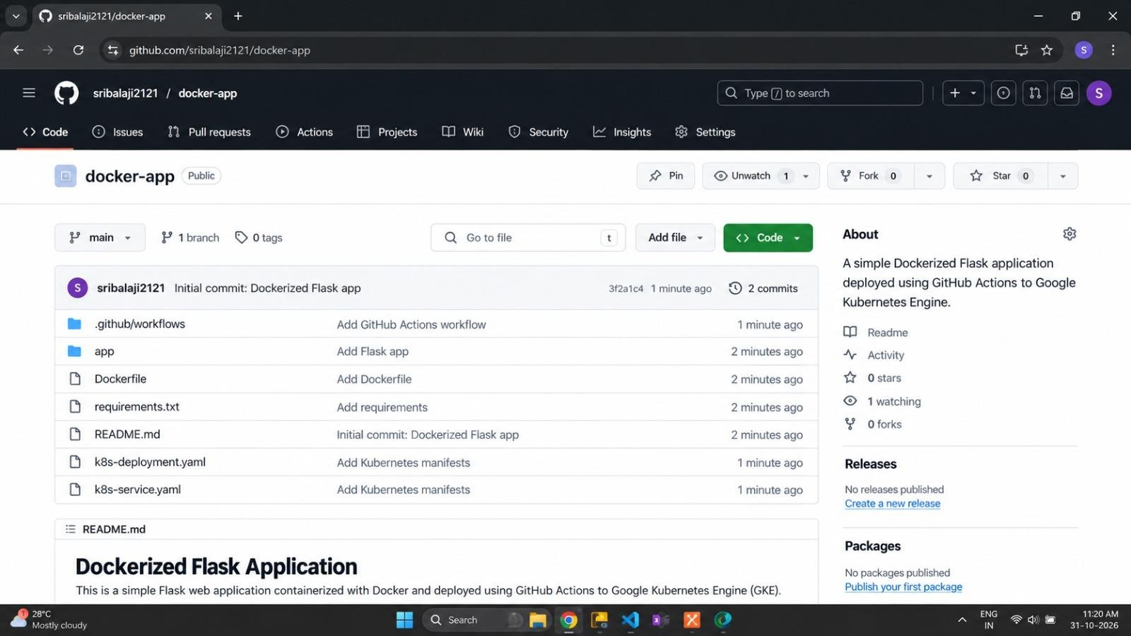
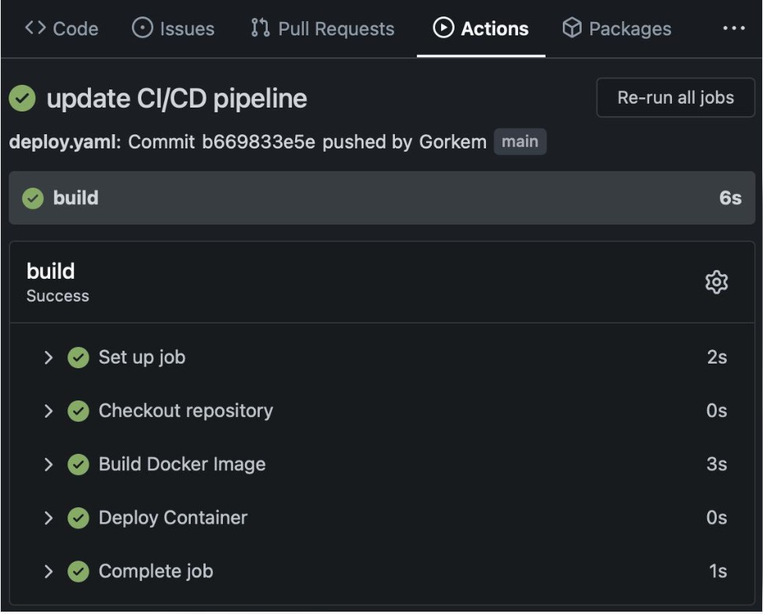

RESULT
Thus, Experiment 14 was carried out according to the given tasks. The expected output and the screenshot evidence are recorded in the original lab document.

Ex 15 Create a GitHub Repository and Implement Version Control Tasks:
- Set up a repository for a team project.
- Create branches for individual modules.
- Merge branches with pull requests after code reviews.
- Resolve conflicts during branch merging.
- Document the workflow using the README file.
- Submit the repository li

AIM
To manage a team project using Git and GitHub through repositories, branches, pull requests, code reviews, and conflict resolution.

PROCEDURE
- Create a GitHub repository for the team project and add a README file describing the project.
- Clone the repository to the local system using git clone.
- Create separate branches for individual modules using git branch or git switch -c.
- Make changes in each branch, stage them, and commit them with meaningful messages.
- Push the branches to GitHub and create pull requests for code review.
- After review, merge the pull requests into the main branch.
- If merge conflicts occur, edit the affected files, remove conflict markers, test the changes, and commit the resolution.
- Update the README with the project details and version-control workflow.

INPUT
GitHub repository URL, project files, branch names, commit messages, and README documentation.

OUTPUT
A shared GitHub repository is maintained with module branches, reviewed pull requests, merged changes, and documented project workflow.

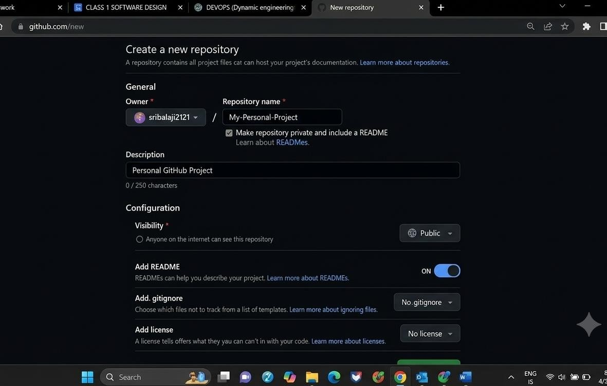

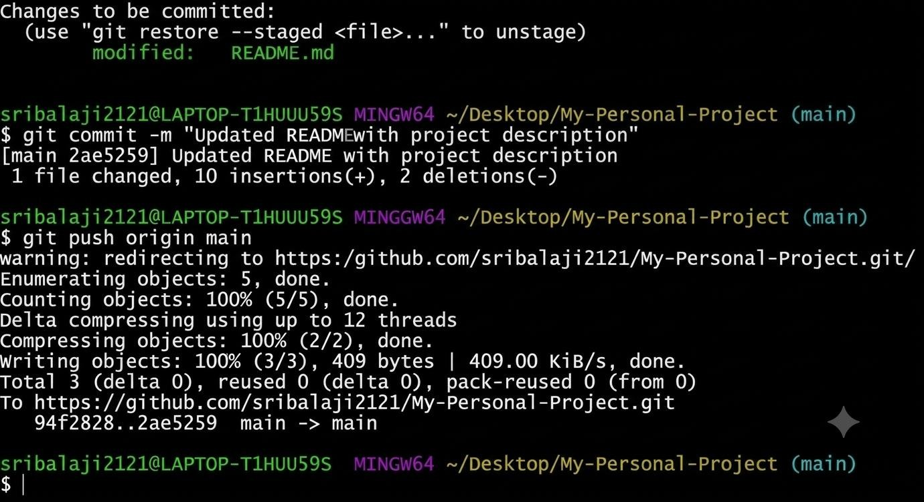

RESULT
Thus, Experiment 15 was carried out according to the given tasks. The expected output and the screenshot evidence are recorded in the original file

